2. MICRO CONTROLLER

2.1 CONCEPTS OF MICROCONTROLLER :
Microcontroller is a general purpose device, which integrates a number of the components of a microprocessor system on to single chip. It has inbuilt CPU, memory and peripherals to make it as a mini computer. A microcontroller combines on to the same microchip:

- The CPU core
- Memory(both ROM and RAM)
- Some parallel digital i/o

Microcontrollers will combine other devices such as:
- A timer module to allow the microcontroller to perform tasks for certain time periods.
- A serial i/o port to allow data to flow between the controller and other devices such as a PIC or another microcontroller.
- An ADC to allow the microcontroller to accept analogue input data for processing.

Microcontrollers are :
- Smaller in size
- Consumes less power
- Inexpensive

Micro controller is a stand alone unit ,which can perform functions on its own without any requirement for additional hardware like i/o ports and external memory.
The heart of the microcontroller is the CPU core. In the past, this has traditionally been based on a 8-bit microprocessor unit. For example Motorola uses a basic 6800 microprocessor core in their 6805/6808 microcontroller devices.
In the recent years, microcontrollers have been developed around specifically designed CPU cores, for example the microchip PIC range of microcontrollers.

2.2 INTRODUCTION TO PIC :
The microcontroller that has been used for this project is from PIC series. PIC microcontroller is the first RISC based microcontroller fabricated in CMOS (complimentary metal oxide semiconductor) that uses separate bus for instruction and data allowing simultaneous access of program and data memory.
The main advantage of CMOS and RISC combination is low power consumption resulting in a very small chip size with a small pin count. The main advantage of CMOS is that it has immunity to noise than other fabrication techniques.

PIC (16F877) :
Various microcontrollers offer different kinds of memories. EEPROM, EPROM, FLASH etc. are some of the memories of which FLASH is the most recently developed. Technology that is used in pic16F877 is flash technology, so that data is retained even when the power is switched off. Easy Programming and Erasing are other features of PIC 16F877.

PIC START PLUS PROGRAMMER :
The PIC start plus development system from microchip technology provides the product development engineer with a highly flexible low cost microcontroller design tool set for all microchip PIC micro devices. The picstart plus development system includes PIC start plus development programmer and mplab ide.
The PIC start plus programmer gives the product developer ability to program user software in to any of the supported microcontrollers. The PIC start plus software running under mplab provides for full interactive control over the programmer.

2.3 SPECIAL FEATURES OF PIC MICROCONTROLLER :
CORE FEATURES :
• High-performance RISC CPU
• Only 35 single word instructions to learn
• All single cycle instructions except for program branches which are two cycle
• Operating speed: DC - 20 MHz clock input
DC - 200 ns instruction cycle
• Up to 8K x 14 words of Flash Program Memory,
Up to 368 x 8 bytes of Data Memory (RAM)
Up to 256 x 8 bytes of EEPROM data memory
• Pin out compatible to the PIC16C73/74/76/77
• Interrupt capability (up to 14 internal/external
• Eight level deep hardware stack
• Direct, indirect, and relative addressing modes
• Power-on Reset (POR)
• Power-up Timer (PWRT) and Oscillator Start-up Timer (OST)
• Watchdog Timer (WDT) with its own on-chip RC Oscillator for reliable operation
• Programmable code-protection
• Power saving SLEEP mode
• Selectable oscillator options
• Low-power, high-speed CMOS EPROM/EEPROM technology
• Fully static design
• In-Circuit Serial Programming (ICSP) via two pins
• Only single 5V source needed for programming capability
• In-Circuit Debugging via two pins
• Processor read/write access to program memory
• Wide operating voltage range: 2.5V to 5.5V
• High Sink/Source Current: 25 mA
• Commercial and Industrial temperature ranges
• Low-power consumption:
< 2mA typical @ 5V, 4 MHz
20mA typical @ 3V, 32 kHz
< 1mA typical standby current

PERIPHERAL FEATURES :
• Timer0: 8-bit timer/counter with 8-bit prescaler
• Timer1: 16-bit timer/counter with prescaler, can be incremented during sleep
via external crystal/clock
• Timer2: 8-bit timer/counter with 8-bit period register, prescaler and postscaler
• Two Capture, Compare, PWM modules
Capture is 16-bit, max resolution is 12.5 ns,
Compare is 16-bit, max resolution is 200 ns,
PWM max. resolution is 10-bit
• 10-bit multi-channel Analog-to-Digital converter
• Synchronous Serial Port (SSP) with SPI. (Master Mode) and I2C. (Master/Slave)
• Universal Synchronous Asynchronous Receiver Transmitter (USART/SCI) with
9- bit address detection.
• Brown-out detection circuitry for Brown-out Reset (BOR)

2.4 ARCHITECTURE OF PIC 16F877 :
The complete architecture of PIC 16F877 is shown in the fig 2.1. Table 2.1 gives details about the specifications of PIC 16F877. Fig 2.2 shows the complete pin diagram of the IC PIC 16F877.

FIG 2.1 ARCHITECTURE OF PIC 16F877

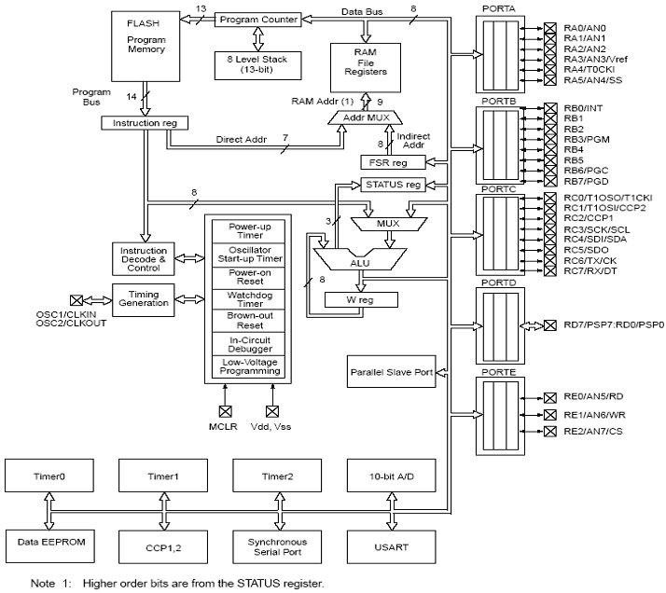
TABLE 2.1 SPECIFICATIONS
DEVICE | PROGRAM FLASH | DATA MEMORY | DATA EEPROM
PIC 16F877 | 8K | 368 Bytes | 256 Bytes

FIG 2.2 PIN DIAGRAM OF PIC 16F877

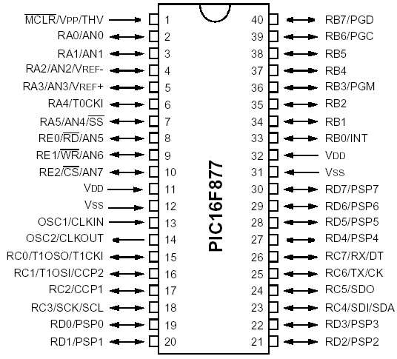
TABLE 2.2 PIN OUT DESCRIPTION
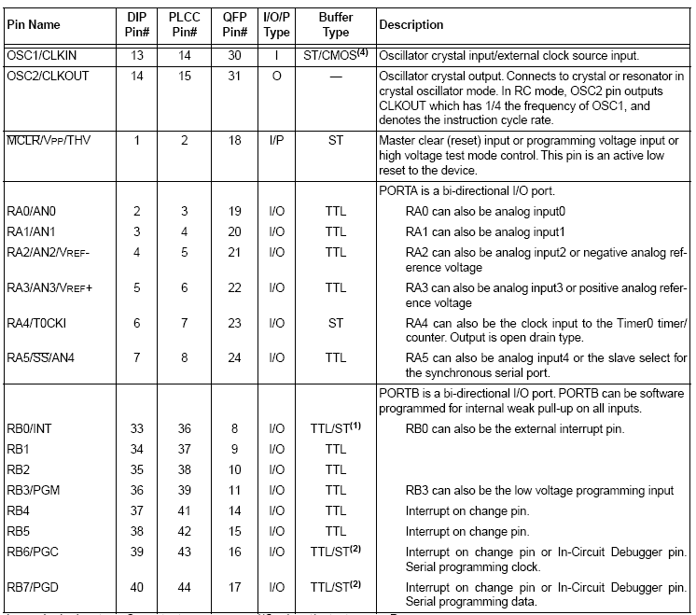
Legend: I = input O = output I/O = input/output P = power
— = Not used TTL = TTL input ST = Schmitt Trigger input
Note
1. This buffer is a Schmitt Trigger input when configured as an external interrupt 2. This buffer is a Schmitt Trigger input when used in serial programming mode.
3. This buffer is a Schmitt Trigger input when configured as general purpose I/O and a TTL
input when used in the Parallel Slave Port mode (for interfacing to a microprocessor bus).
4. This buffer is a Schmitt Trigger input when configured in RC oscillator mode and a
CMOS input otherwise.

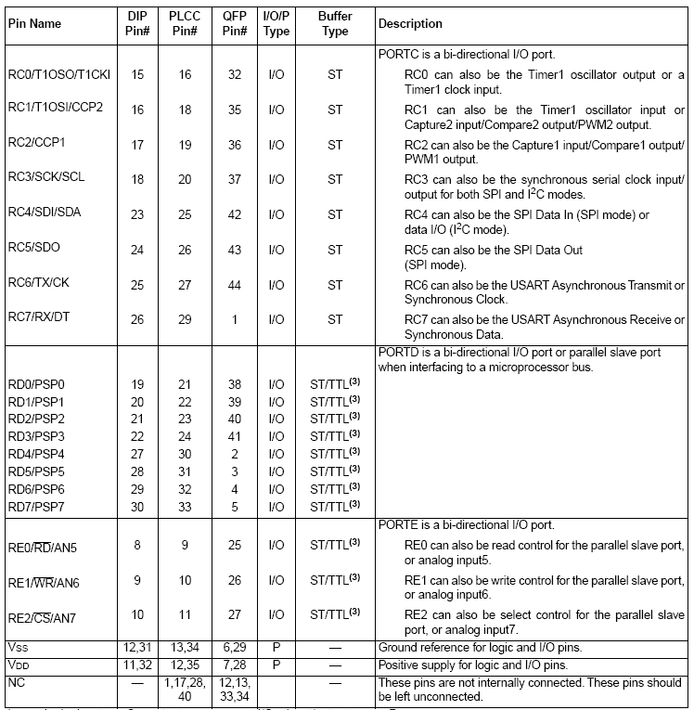
Legend: I = input O = output I/O = input/output P = power
— = Not used TTL = TTL input ST = Schmitt Trigger input
Note :
1. This buffer is a Schmitt Trigger input when configured as an external interrupt.
2. This buffer is a Schmitt Trigger input when used in serial programming mode.
3. This buffer is a Schmitt Trigger input when configured as general purpose I/O and a TTL
input when used in the Parallel Slave Port mode (for interfacing to a microprocessor bus).
4. This buffer is a Schmitt Trigger input when configured in RC oscillator mode and a
CMOS input otherwise.

2.5 I/O PORTS :
Some pins for these I/O ports are multiplexed with an alternate function for the peripheral features on the device. In general, when a peripheral is enabled, that pin may not be used as a general purpose I/O pin.
Additional Information on I/O ports may be found in the IC micro™ Mid-Range Reference Manual,

PORTA AND THE TRISA REGISTER :
PORTA is a 6-bit wide bi-directional port. The corresponding data direction register is TRISA. Setting a TRISA bit (=1) will make the corresponding PORTA pin an input, i.e., put the corresponding output driver in a Hi-impedance mode. Clearing a TRISA bit (=0) will make the corresponding PORTA pin an output, i.e., put the contents of the output latch on the selected pin. Reading the PORTA register reads the status of the
pins whereas writing to it will write to the port latch. All write operations are read-modify-write operations. Therefore a write to a port implies that the port pins are read; this value is modified, and then written to the port data latch. Pin RA4 is multiplexed with the Timer0 module clock input to become the RA4/T0CKI pin. The RA4/T0CKI pin is a Schmitt Trigger input and an open drain output. All other RA port pins have TTL input levels and full CMOS output drivers. Other PORTA pins are multiplexed with analog inputs and analog VREF input. The operation of each pin is selected by clearing/setting the control bits in the ADCON1 register (A/D Control Register1).
The TRISA register controls the direction of the RA pins, even when they are being used as analog inputs. The user must ensure the bits in the TRISA register are maintained set when using them as analog inputs.

TABLE 2.3 PORT A FUNCTION
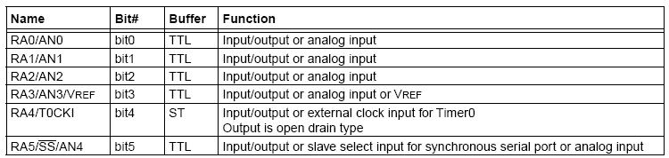
Legend: TTL = TTL input, ST = Schmitt Trigger input

TABLE 2.4 SUMMARY OF REGISTERS ASSOCIATED WITH PORTA

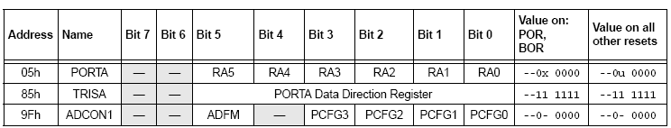
Legend: x = unknown, u = unchanged, - = unimplemented locations read as '0'. Shaded cells are not used by PORTA.

PORTB AND TRISB REGISTER :

PORTB is an 8-bit wide bi-directional port. The corresponding data direction register is TRISB. Setting a TRISB bit (=1) will make the corresponding PORTB pin an input, i.e., put the corresponding output driver in a hi-impedance mode. Clearing a TRISB bit (=0) will make the corresponding PORTB pin an output, i.e., put the contents of the output latch on the selected pin. Three pins of PORTB are multiplexed with the Low Voltage Programming function; RB3/PGM, RB6/PGC and RB7/PGD. The alternate functions of these pins are described in the Special Features Section. Each of the PORTB pins has a weak internal pull-up. A single control bit can turn on all the pull-ups.
This is performed by clearing bit RBPU (OPTION_REG<7>). The weak pull-up is automatically turned off when the port pin is configured as an output. The pull-ups are disabled on a Power-on Reset.

Four of PORT B’s pins, RB7:RB4, have an interrupt on change feature. Only pins configured as inputs can cause this interrupt to occur (i.e. any RB7:RB4 pin configured as an output is excluded from the interrupt on change comparison). The input pins (of RB7:RB4) are compared with the old value latched on the last read of PORTB. The “mismatch” outputs of RB7:RB4 are OR’ed together to generate the RB Port Change Interrupt with flag bit RBIF (INTCON<0>). This interrupt can wake the device from SLEEP. The user, in the interrupt service routine, can clear the interrupt in the following manner:
a) Any read or write of PORTB. This will end the mismatch condition.
b) Clear flag bit RBIF. A mismatch condition will continue to set flag bit RBIF. Reading PORTB will end the mismatch condition, and allow flag bit RBIF to be cleared. The interrupt on change feature is recommended for wake-up on key depression operation and operations where PORTB is only used for the interrupt on change feature. Polling of PORTB is not recommended while using the interrupt on change feature. This interrupt on mismatch feature, together with software configurable pull-ups on these four pins, allow easy interface to a keypad and make it possible for wake-up on key depression

TABLE 2.5 PORT B FUNCTIONS
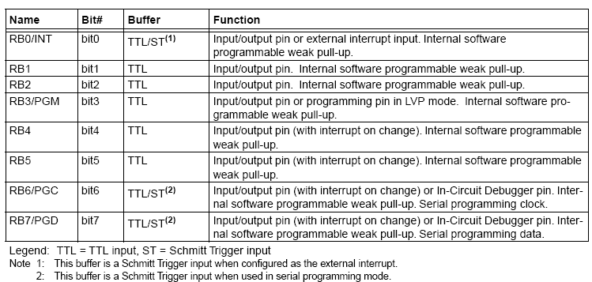

TABLE 2.6 SUMMARY OF REGISTERS ASSOCIATED WITH PORTB

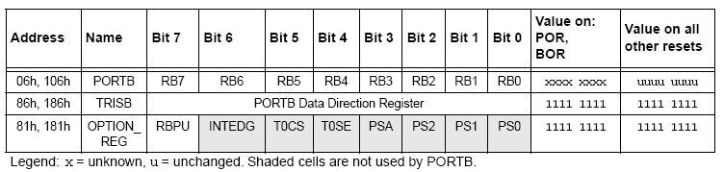

PORTC AND THE TRISC REGISTER :
PORTC is an 8-bit wide bi-directional port. The corresponding data direction register is TRISC. Setting a TRISC bit (=1) will make the corresponding PORTC pin an input, i.e., put the corresponding output driver in a hi-impedance mode. Clearing a TRISC bit (=0) will make the corresponding PORTC pin an output, i.e., put the contents of the output latch on the selected pin. PORTC is multiplexed with several peripheral functions. PORTC pins have Schmitt Trigger input buffers.

When the I2C module is enabled, the PORTC (3:4) pins can be configured with normal I2C levels or with SMBUS levels by using the CKE bit (SSPSTAT <6>). When enabling peripheral functions, care should be taken in defining TRIS bits for each PORTC pin. Some peripherals override the TRIS bit to make a pin an output, while other peripherals override the TRIS bit to make a pin an input. Since the TRIS bit override is in effect while the peripheral is enabled, read-modify write instructions (BSF, BCF, XORWF) with TRISC as destination should be avoided. The user should refer to the corresponding peripheral section for the correct TRIS bit settings.

TABLE 2.7 PORTC FUNCTIONS
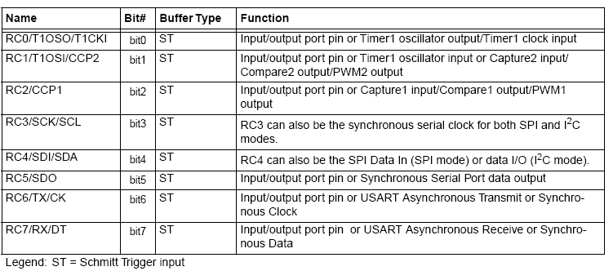

TABLE 2.8 SUMMARY OF REGISTERS ASSOCIATED WITH PORTC
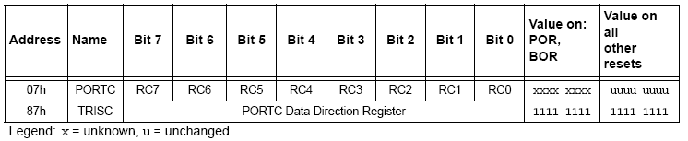

PORTD AND TRISD REGISTERS :
This section is not applicable to the 28-pin devices. PORTD is an 8-bit port with Schmitt Trigger input buffers. Each pin is individually configurable as an input or output. PORTD can be configured as an 8-bit wide microprocessor Port (parallel slave port) by setting control bit PSPMODE (TRISE<4>). In this mode, the input buffers are TTL.

TABLE 2.9 PORTD FUNCTIONS
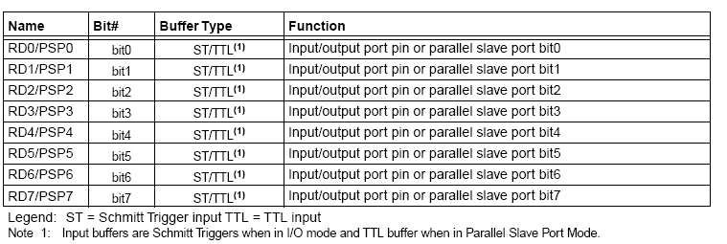

TABLE 2.10 SUMMARY OF REGISTERS ASSOCIATED WITH PORTD
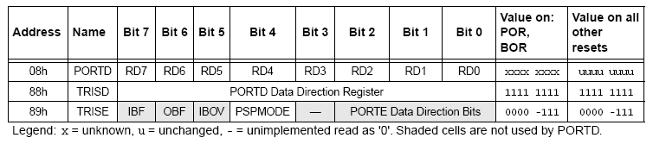

PORTE AND TRISE REGISTER :
PORTE has three pins RE0/RD/AN5, RE1/WR/AN6 and RE2/CS/AN7, which are individually configurable as inputs or outputs. These pins have Schmitt Trigger input buffers.
The PORTE pins become control inputs for the microprocessor port when bit PSPMODE (TRISE<4>) is set. In this mode, the user must make sure that the TRISE<2:0> bits are set (pins are configured as digital inputs). Ensure ADCON1 is configured for digital I/O. In this mode the input buffers are TTL.
PORTE pins are multiplexed with analog inputs. When selected as an analog input, these pins will read as '0's. TRISE controls the direction of the RE pins, even when they are being used as analog inputs. The user must make sure to keep the pins configured as inputs when using them as analog inputs.

TABLE 2.11 PORTE FUNCTIONS
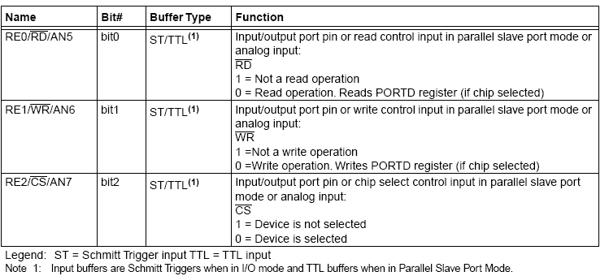

TABLE 2.12 SUMMARY OF REGISTERS ASSOCIATED WITH PORTE
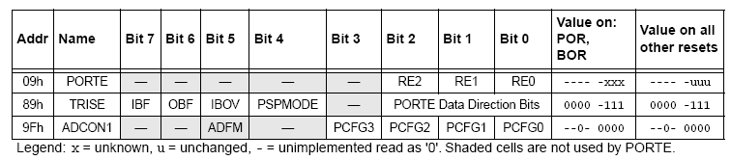
2.6 MEMORY ORGANISATION :
There are three memory blocks in each of the PIC16F877 MUC’s. The program memory and Data Memory have separate buses so that concurrent access can occur.

PROGRAM MEMORY ORGANISATION :
The PIC16f877 devices have a 13-bit program counter capable of addressing 8K *14 words of FLASH program memory. Accessing a location above the physically implemented address will cause a wraparound.
The RESET vector is at 0000h and the interrupt vector is at 0004h.

DATA MEMORY ORGANISTION :
The data memory is partitioned into multiple banks which contain the General Purpose Registers and the special functions Registers. Bits RP1 (STATUS<6) and RP0 (STATUS<5>) are the bank selected bits.
RP1:RP0 | Banks
00 | 0
01 | 1
10 | 2
11 | 3

Each bank extends up to 7Fh (1238 bytes). The lower locations of each bank are reserved for the Special Function Registers. Above the Special Function Registers are General Purpose Registers, implemented as static RAM. All implemented banks contain special function registers. Some frequently used special function registers from one bank may be mirrored in another bank for code reduction and quicker access.

PIC16F877 REGISTER FILE MAP
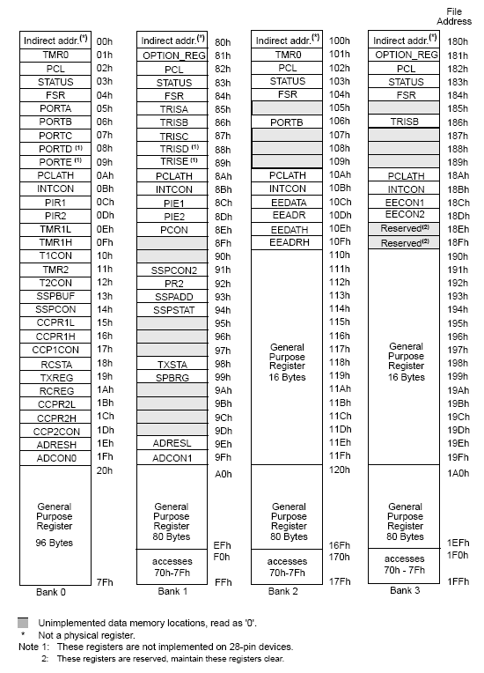

GENERAL PURPOSE REGISTER FILE :
The register file can be accessed either directly or indirectly through the File Selected Register (FSR). There are some Special Function Registers used by the CPU and peripheral modules for controlling the desired operation of the device. These registers are implemented as static RAM. The Special Function Registers can be classified into two sets; core (CPU) and peripheral. Those registers associated with the core functions.

2.7 INSTRUCTION SET SUMMARY :
Each PIC 16f877 instruction is a 14-bit word, divided into an OPCODE which specifies the instruction type and one or more operand which further specify the operation of the instruction. The PIC16F877 instruction set summary in Table 2.13 lists byte-oriented, bit-oriented, and literal and control operations. It shows the opcode Field descriptions.

TABLE 2.13 OPCODE FIELD DESCRIPTIONS

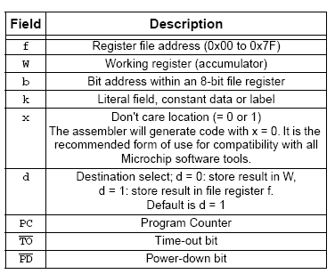
For byte-oriented instructions, ‘f’ represents a file register designator and ’d’ represents a destination designator. The file register designator specifies which file register is to be used by the instruction. The destination designator specified where the result of the operation is to be placed. If ‘d’ is zero, the result is placed in the w register. If ‘d’ is one, the result is placed in the file register specified in the instruction.

For bit-oriented instructions, ‘b’ represents a bit field designator which selects the number of the bit affected by the operation, which ‘f’ represents the address of the file in which the bits is located. For literal and control operations, ‘k’ represents an eight or eleven bit constant or literal value.

The instruction set is highly orthogonal and is grouped into three basic categories:
• Byte-oriented operations
• Bit-oriented operations
• Literal and control operations
All instructions are executed within one single instruction cycle, unless a conditional test is true or the program counter is changed as a result of an instruction. In this case, the execution takes two instruction cycles with the second cycle executed as a NOP. One instruction cycle consists of four oscillator periods. Thus, for an oscillator frequency of 4 MHz, the normal instruction execution time is 1 ms. If a conditional test is true or the program counter is changed as a result of an instruction, then the instruction execution time is 2 ms.

TABLE 2.14 16F877 INSTRUCTION SET
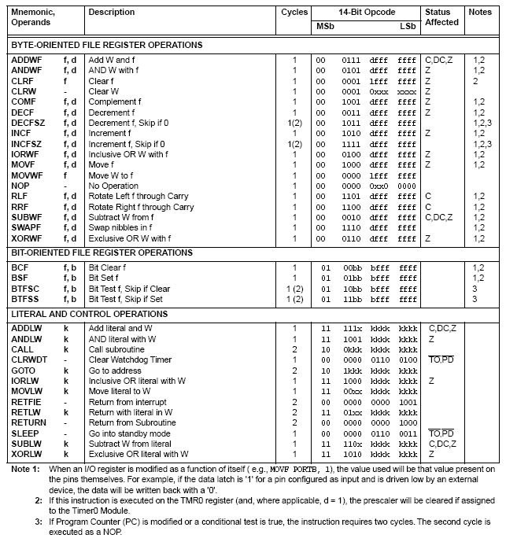
GENERAL FORMAT FOR INSTRUCTIONS :

